**Anticancer Activities of Thai Traditional Herbal Formulae *In Vitro***

CHATCHAYA NANGSUE1, KIATTAWEE CHOOWONGKOMON2, WICHUDA THONGPUEG2, CHAINARONG TOCHARUS3, PUSSADEE SRATHONG4*

1Faculty of Medicine

Chiang Mai University

110 Intawaroros Road, Suthep, Mueang Chiang Mai District, Chiang Mai 50200

THAILAND

2Department of Biochemistry, Faculty of Science

Kasetsart University, Bangkok 10900

THAILAND

3Department of Anatomy, Faculty of Medicine

Chiang Mai University, Chiang Mai 50200

THAILAND

4Prachomklao College of Nursing, Phetchaburi 7600

THAILAND

*Abstract: -* The global burden of disease is predominated by cancer, a chronic illness that threatens quality of life, physical, and mental health. On a wider aspect, economic resources are pooled into cancer treatments that have significant repercussions such as inevitable side effects that lead to depression, this accentuates the need for a more efficacious cure with less adversities and financial expenses. Since ancient times, Thai traditional herbal medicine has been deployed to maintain good health, relieve ailments and prevent diseases through a holistic approach. In prevailing times, many have sought out herbal remedies as a first choice, or as complementary medicine especially when modern treatment options were ineffective or resulted in severe health consequences, especially now with the rise in scientific evidence to discover the herbs’ mechanisms of action in fighting disease. In this research, the efficacy of 21 Thai traditional herbal formulas on killing cancer cells *in vitro* is reported, along with a review of their benefits and effects on the body and a diverse range of medical conditions which further contribute to manipulation of the tumor microenvironment. These herbs are safe without detrimental side effects, effective, and an economical solution especially for developing countries to fight cancer without the impact of the burden of disease on daily lives. This study explores the *in vitro* anticancer effect of 21 Thai traditional herbal formulas via cytotoxicity assays on 11 cancer cell lines and a normal cell line (Vero). Their anticancer activity was determined by 3-[4,5-dimethylthiazol-2-yl]-2,5 diphenyl tetrazolium bromide (MTT) assay, and the half-maximal inhibitory concentrations (IC50) were calculated for the A431, HCT-116, HepG2, MCF-7, A549, SW480, Hela, NCI-H1975, Vero, RBE, and SK-OV-3 cell lines. The best effectiveness of cancer growth inhibition was by Beta V on RBE cells at an IC50 of 27.13 ± 9.826 μg/dL and at comparable levels, the A549 cell line was inhibited greatly by Kerrix Plus, Rizz, Merdana, and RID-ZY. The findings conclude that the Thai traditional herbal formulas can inhibit proliferation of different types of cancer cells. From our results, the 21 herbal remedies may benefit as complementary and alternative medicine to conventional cancer interventions, be economical for wide-scale use, and alleviate wellbeing significantly for advanced stage cancer patients by minimizing adverse events.

*Keywords: -*Thai herb; Anticancer; Anti-inflammation; Cytotoxic; Cell culture; Phytochemistry

Received: May 31, 2019. Revised: May 4, 2020. Accepted: May 22, 2020. Published: May 29, 2020   
(Τhe Organizers will fill these dates in case of final acceptance, following strictly our data base and possible email communication).

**1 Introduction**

The impending global burden of cancer has always weighed upon a myriad of aspects of health, society, healthcare, and economies and continues to pose a threat with the increasing trend. A stark 77% increase in the incidence of cancer is predicted in 2050 at above 35 million cases compared to 20 million in 2022 despite cancer research worldwide to put a stop to this threat to global health goals and welfare [1]. Devastatingly, this shows that innovative prevention techniques and screening may not be able to handle the depth of this rising issue. In 2019, over 44% of death in cancer patients were attributable to known risks [2].

Thus, current treatments, preventions, and support for cancer patients must be ameliorated to pertain to the shocking rise in cases, and efforts must be made to prevent such circumstances. When one is diagnosed with cancer, there is often a preconception that there is no cure. This may partly be true as modern therapies may be efficacious, however, bringing along adverse events both known and unfathomable, varying in severity and there is also a chance of recurrence of cancer along the line despite an unfortunate extended journey of therapy already. Therefore, alternative and complementary medicine is vital for patients and could be the solution to all current issues concerned with cancer treatment. Furthermore, Thai herbs are known for mechanisms in preventing cancer. This can have a role in the depletion of predicted new cases and decrease the toll on society.

# Thai herbs derived from ancient medicinal practices have been routinely used since ancient times to relieve symptoms and prevent severe illness. During the COVID-19 pandemic an opulence of people chose Thai herbal remedies like *Andrographis paniculata* for treatment of symptoms at home, as hospitals were overflowed with patients. Even after the arrival of vaccines, COVID-19 was still spreading and some susceptible groups also remained like immunocompromised patients whose vaccine efficacy was being researched [3]. COVID-19 incidence is often not accurate as all cases are not reported so there have been estimators that calculated the incidence, indicating that cases may have gone down but continue to affect our lives [4-6]. An intriguing herbal formula that came of great use during the pandemic is Kerra, not only does it have anti-inflammatory properties preventing the cytokine storm that causes severe COVID-19 infection, it can also inhibit viral replication enzymes in SARS-CoV-2. Furthermore, it is still in use after the global crisis and has credible research to support its properties of anti-inflammation and anti-cancer activities through apoptosis. The Kerra extract can inhibit growth of various cancer cell types and is recommended especially for a good quality of life for advanced cancer patients [7]. It also has been proved to be an antiviral against HIV [8]. A study found that *Dracaena loureiri* had significant cytotoxic effects on A549 cells of non-small-cell lung cancer [9]. These ancient herbal remedies are deemed to be safe and are appealing due to cost-effectiveness available for household utilization.

Conversely, in Thailand there are cultural practices claiming herbal cures with unknown ingredients that do more harm than good. In the north of Thailand there are mountain villages and rural areas where certified healthcare practices are not easily accessible. These people are often given drugs such as corticosteroids that lead to worsening of their current condition along with long term side effects such as immunosuppression and Cushing’s syndrome. This highlights the importance of a proper market for the distribution of authentic herbs backed by evidence of safety profiles and effectiveness, so that alternative options to healthcare services are always available to people no matter where they live.

Multiple cancers have attributable risks ranging from behavioural, metabolic, environmental, and occupational. Many are modifiable risks that can be mitigated with suitable education and prevention however, environmental factors such as pollution are more difficult to tackle such as fine particulate matter 2.5 (PM2.5) that has been a threatening issue in Thailand and many countries for decades. There has been a significant increase in lung cancer cases due to PM2.5 over the past years. Efforts have been made to solve the problem including estimators to predict the seasonal rise of pollution in various provinces in Thailand [10-13] but the means to decrease PM2.5 are insubstantial so the rise is barely preventable. Kerra can prevent mutation of EGFR stopping cells exposed to pollution from becoming cancer.

The anticancer activities of 21 Thai traditional herbal formulas are explored in this paper, including a review of their unique properties. They tackle cancer and diverse diseases via a holistic approach of maintaining a balance in the human body using synergistic effects of the phytochemicals. Thai traditional herbal medicine is believed to have originated from Ayurvedic medicine. Thai medicinal practices using herbs have been traced back to healthcare places in 1182 AD including herbal formulae written on stone inscriptions that have been passed down to the present generation. The herbs in this study in the present day have evidence shown from self use by the general population, are certified on the market including regulated distribution of the drugs, and have growing reliable scientific evidence. These herbs optimize functioning of organ systems, maintain normal flora in the gut important for the immune system, and regulate inflammation. These effects synergistically lead to the prevention and treatment of chronic diseases including infections, cancer, autoimmune and inflammatory conditions, and diabetes mellitus and its complications. The herbs in this paper are currently used as an amalgamation to treat patients with severe conditions afflicting their lifestyles such as pressure ulcers, metastasized cancer and recurrence, diabetic foot ulcers, lymphatic disorders, autoimmune and inflammatory disorders, and infections. This alternative to modern medicine has yielded successfulness in alleviation of tormenting symptoms and maintaining a normal quality of life without side effects or requiring long term hospitalization and supportive care and can also be used alongside current therapeutic options. The active ingredients of the herbal formulae are given in Table S1. Some additional properties of the herbs are shown in Table 1.

Table 1. List of herbal formulae and their additional properties

|  | **Herbal Fomulae** | **Additional Properties** |
| --- | --- | --- |
| 1 | IM-1 | Prevents non communicable diseases, improves lymphatic disorders, boosts immune system, anti-inflammatory, promotes wound healing |
| 2 | Beta V |
| 3 | Beta G |
| 4 | IM-7 |
| 5 | Kerrix Plus |
| 6 | LIVOXY |
| 7 | IM-5 |
| 8 | Renex |
| 9 | Beta X | Maintains normal liver and kidney function, antioxidant |
| 10 | RID-ZY | Relieves hemorrhoids |
| 11 | Absorn | Improves irregular menstrual cycles |
| 12 | Bova | Relieves flatulence, dizziness |
| 13 | Zaminzyme | Hair growth, prevents hair loss, anti-inflammation, improves GI normal flora balance |
| 14 | Hepa Plus | Helps normal liver and kidney function |
| 15 | Hepa 2 | Lymphatic disorders, maintains normal liver and kidney function |
| 16 | Derris Scandends Benth Capsule | Relieves muscle pain |
| 17 | Venta |
| 18 | Belax | Relieves constipation, is a laxative |
| 19 | Rizz | Relieves hemorrhoids |
| 20 | MINOZA | Treatment of lymphatic disorders, diabetes mellitus |
| 21 | Merdana | Relieves rashes, dermatitis, and psoriasis |

**2 Materials and Methods**

**2.1 Compound preparation**

The powders from the herbal capsules were dissolved with 100% DMSO to reach a solution of 100 mg/mL, then the samples were diluted by 100 times and filtered by an ultrafilter membrane of 0.2 micrometres and then stored at -20 C.

**2.2** **Cell culture**

All cell types included 10% fetal bovine serum (FBS) and 1% penicillin/streptomycin. The incubator conditions for cell culture were a humidified atmosphere of 5% CO2 at a temperature of 37°C.

**2.3** **Cytotoxicity assay**

We determined cancer cell growth inhibition using the MTT test. The change of a tetrazolium dye to an insoluble formazan compound by viable cells was measured. Cancer cells were placed in 96-well plates with a density of 6 × 103 cells per well. The plates were incubated overnight at 37 °C with 5% CO2. Then the cells were treated with 100 μL of varying concentrations of each herb in ethanol solution and incubated for 72 hours. The culture medium was updated to 100 μL of 3-[4,5-dimethylthiazol-2-yl]-2,5 diphenyl tetrazolium bromide (MTT) (Thermo Fisher Scientific, USA) solution (0.5 mg MTT in 1 mL culture medium) and incubated at 37 °C for 3 hours. Then the medium was discarded and 50 μL of DMSO was placed in each well for solubilization of formazan. The absorbance of each well was measured at 570/630 nm using a microplate spectrophotometer (Synergy HTX Multi-Mode reader, BioTek, USA). The half-maximal inhibitory concentration (IC50) values were acquired using the absorbance of the herb-treated wells to the untreated control. All experiments were done in triplicate.

**2.4 Statistical analysis**

The IC50 values and coefficient of determination (R2) were determined using the concentration of each herb and the respective percent inhibition of each cell line from triplicate experiments using the GraphPad Prism Software Version 10.0.0.

**3 Results**

**3.1** **Anticancer activity and safety**

The cancer cytotoxicity comparison between the 21 Thai traditional herbal formulas on 11 cancer cell lines and a normal cell line (Vero) is shown in Table 2.

Table 2. Cytotoxic effects comparison in different cell lines

Table 2. continued

Table 2. continued

Table 2. continued

The in vitro tests in Table 2. show that the herbs are effective at inhibiting the proliferation of cancer cells according to their cytotoxicity on the A431 (epidermoid carcinoma), HCT-116 (colorectal carcinoma), HepG2 (hepatocellular carcinoma), MCF-7 (human breast cancer with positive estrogen, progesterone, and glucocorticoid receptors), A549 (adenocarcinoma of human alveolar basal epithelial cell), SW480 (colon adenocarcinoma), Hela (cervical cancer), NCI-H1975 (non-small cell lung carcinoma), RBE (cholangiocarcinoma), and SK-OV-3 (ovarian adenocarcinoma) but are safe to normal cells including Vero (African green monkey kidney epithelial normal cell). The IC50 values show that the 21 herbal formulae have anticancer potential for alternative and complementary cancer treatment.

The best effectiveness of cancer growth inhibition was by Beta V on RBE cells at an IC50 of 27.13 ± 9.826 μg/dL and at comparable levels, the A549 cell line was inhibited greatly by Kerrix Plus, Rizz, Merdana, and RID-ZY, respectively. For the A431 cells, Ziminzyme had the optimum IC50 value, whereas Hepa 2, Derris Scandends Benth, Venta, and Renex were comparable. The HCT-116 cells were inhibited efficaciously by Beta X and LIVOXY. The HepG2 cell line’s growth was deterred by Minoza but MCF-7 by Beta X, Beta G, IM-1, Merdana, and Beta-V respectively. The A549 cells were inhibited best by Merdana, RID-ZY, Rizz, and Kerrix Plus. Minoza killed theSW480 cells, where the Hela and NCI-H1975 cells were killed by Merdana. RBE was killed by 5 herbal formulae and included the optimal IC50 for all the experiments. IM-5 worked best on the SK-OV-3 cells. The herbs did not show cytotoxic effects to Vero which are normal cells. Some experiments were not conducted. The dose-dependent inhibition activities of the herbs giving the best results on the cancer cells are shown in Figures 1-7. The IC50 is represented as the mean ±SD of triplicate experiments.

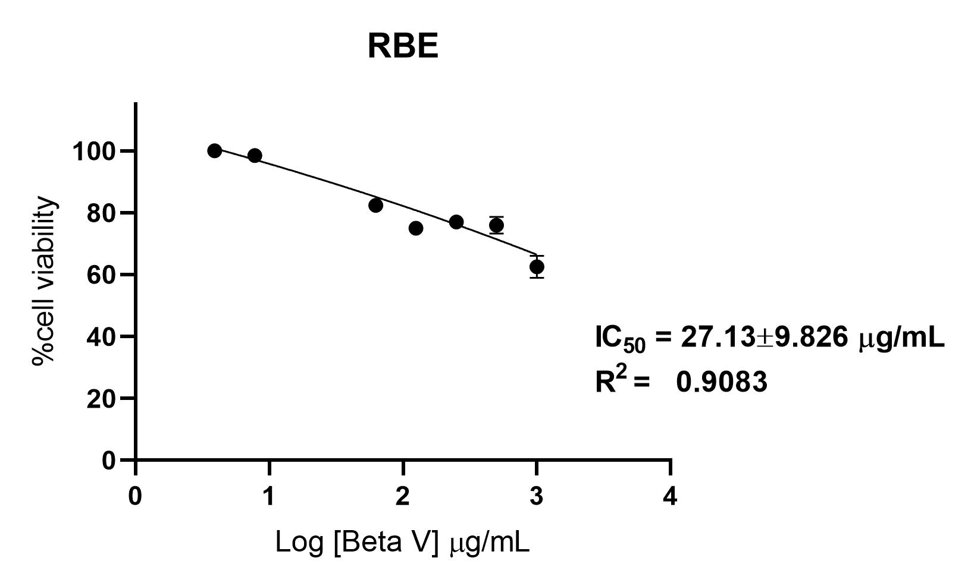

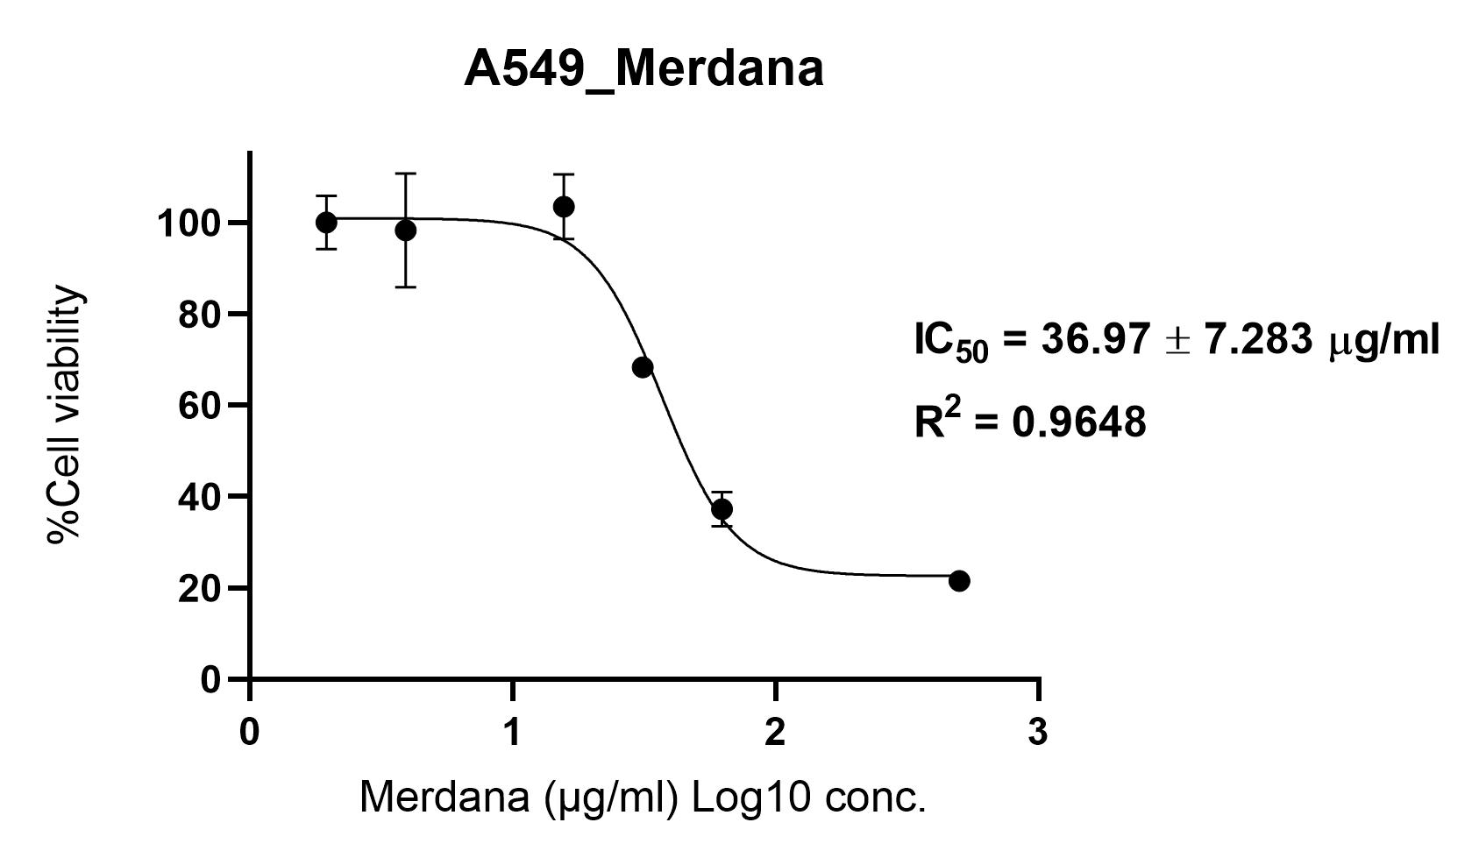Figure 1. Beta V on RBE cell line growth inhibition

Figure 2. Merdana on A549 cell line growth inhibition

Figure 3. Merdana on Hela cell line growth inhibition

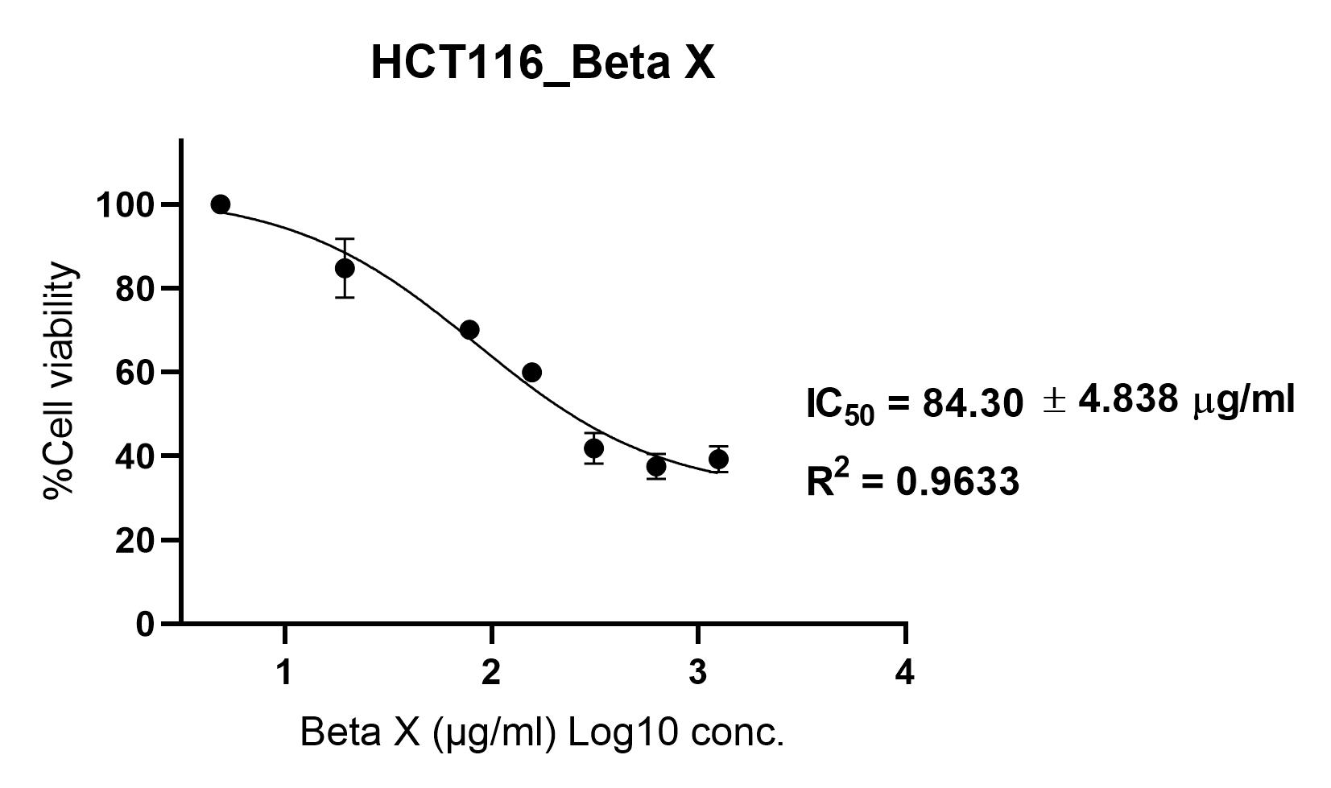

Figure 4. Beta X on HCT-116 cell line growth inhibition

Figure 5. Beta X on MCF-7 cell line growth inhibition

Figure 6. Beta G on MCF-7 cell line growth inhibition

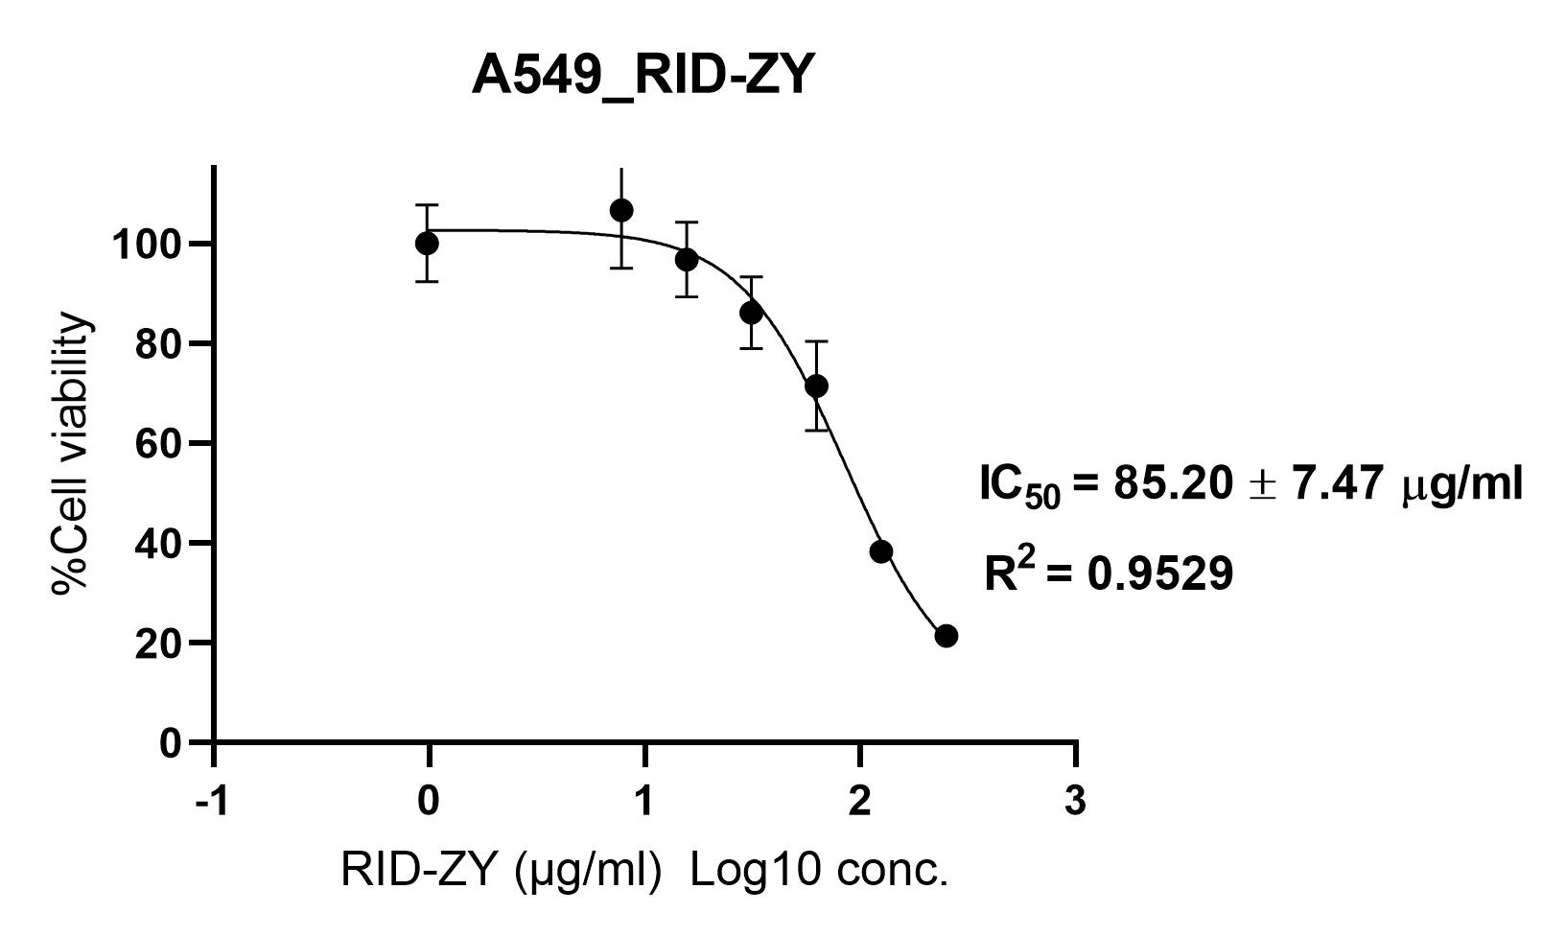

Figure 7. RID-ZY on A549 cell line growth inhibition

# **4 Conclusion and Discussion**

This *in vitro* study reveals an abundance of 21 Thai traditional herbal formulae that are effective against 11 cancer cell lines and a normal cell line, used as alternative approaches to current cancer therapy with no severe adverse effects. The herbal formulae can not only treat but also prevent many diseases through their synergistic properties leading to a holistic approach of sustaining a balance in the body. Properties such as maintaining normal functioning of visceral organs, antioxidant effects, immunomodulation, and anti-inflammation all benefit toward the treatment of cancer. Although there are differences in the IC50 values of the herbs, they can be used as a combination in cancer patients and do not cause toxic effects on the liver. They are also currently used in real cancer patients in Thailand whose conditions significantly improve regardless of cancer stage after using the herbs as complementary or alternative medicine. All herbal extracts can be taken orally and is life changing compared to chemotherapy or radiation therapy requiring multiple hospital visits.

Similar results have been found in other *in vitro* studies for Thai herbal medicine including herbs inducing apoptosis in a chondrosarcoma cell line [14] and ovarian cancer cell line [15]. Furthermore, clinical studies have proven intriguing results. A randomized controlled study (RCT) found that Chinese traditional herbal medicine was superior to transarterial chemoembolization in decreasing recurrence of small hepatocellular carcinoma after surgery and better for overall survival [16]. Another RCT found traditional Chinese medicine maintenance treatment ameliorated patients' quality of life and had a significantly higher 1-year survival rate compared to chemotherapy in advanced non-small-cell lung cancer patients without progression following first-line chemotherapy [17]. A RCT including patients with persistent high risk-HPV infection found that receiving Erhuang suppository, a traditional Chinese medicine can treat high risk-HPV infection [18].  These results strengthen herbal medicine’s effectiveness in cancer. On the contrary, some safety profiles remain unknown when it comes to potential drug-herb interactions in complementary medicine with conventional cancer therapy. An abundance of anticancer drug-herb interactions were found by a scoping review on anticancer drugs from Thailand’s National List of Essential Medicines in 2020 and Thai herbs, where most interactions involved CYP inhibition which could interfere with drug pharmacokinetics [19].

Further studies are warranted to ensure safety of herbal use on a wide-scale and in minor populations that could have different reactions to treatment. Current preclinical studies and general use in the population has proved to be successful and safe without severe adverse events and has markedly improved the quality of life of advanced stage cancer patients in Thailand.

The 21 herbal formulae are derived from ancient medical practices that protect against all diseases varying from infectious to autoimmune as their phytochemicals combine producing a holistic effect allowing the body to be in optimal condition, unimpaired by the disease, while the phytochemicals themselves can also affect and treat the disease. The herbal extracts have many bioactive constituents that additively become potent through many mechanisms whilst decreasing side effects and toxicity, whereas modern drugs require high doses of a single substance that attack only one target and increases toxic effects. Therefore, novel drug interventions are imperative, and ethnomedicine that has been around since ancient times may be the answer.

In this study, many experiments have not been conducted which could yield further results. Further research is warranted to investigate the effectiveness and safety profiles of the herbal medicine in pharmacokinetics and extensive clinical trials, to find its potential in launching as the cure for cancer. This collection of Thai traditional herbs are increasingly becoming available for public use, and may soon become a main complementary and alternative medicine for cancer patients that can ameliorate wellbeing during and after cancer therapy. Herbal formulae provide an efficient, economical, and safe solution, that is imperative to push forward with scientific research for the benefit of mankind.

*Acknowledgement:*

We appreciate all unknown referees for their invaluable comments.

*References:*

1. World Health Organization, Global cancer burden growing, amidst mounting need for services, February 1, 2024. https://www.who.int/news/item/01-02-2024-global-cancer-burden-growing--amidst-mounting-need-forservices#:~:text=Projected%20cancer%20burden%20increase%20in,20%20million%20cases%20in%202022.
2. Tran, Khanh Bao et al. The global burden of cancer attributable to risk factors, 2010–19: a systematic analysis for the Global Burden of Disease Study 2019, *The Lancet*, Vol.400, No.10352, pp.563 - 591
3. Nangsue, C., Srisurapanont, K., Sudjaritruk, T. A Comparison of the Immunogenicity and Safety of an Additional Heterologous versus Homologous COVID-19 Vaccination among Non-Seroconverted Immunocompromised Patients after a Two-Dose Primary Series of mRNA Vaccination: A Systematic Review and Meta-Analysis. *Vaccines*, Vol.12, No.5, 2024, pp.468.
4. Thongsak, N., Lawson, N. A Combined Transformed Variable for Population Mean Estimators When Missing Data Occur with an Application to COVID-19 Incidence. *WSEAS Transactions on Systems and Control*, Vol.18, 2023, pp. 409-415.
5. Ponkaew, C., Lawson, N. New Product Estimators for Population Mean Under Unequal Probability Sampling with Missing Data: A Case Study on the Number of New COVID-19 Patients. *Thailand Statistician,* Vol.22, No.3, 2024, pp. 634-656.
6. Thongsak, N., Lawson, N. Transformed Regression Type Estimators in the Presence of Missing Observations: Case Studies on COVID-19 Incidence in Chiang Mai, Thailand. *WSEAS Transactions on Biology and Biomedicine*, Vol. 21, 2024, pp.131-137.
7. Nangsue, C., Srathong, P., Choowongkomon, K., Promnikorn, K., Tocharus. C., Anticancer Activity of the Thai Herbal Formula “Kerra” Versus Afatinib and Doxorubicin *In Vitro*. *WSEAS Transactions on Biology and Biomedicine*, Vol. 21, 2024, pp. 155-161.
8. Saehlee, S., Seetaha, S., Klankaew, W., Srathong, P., Choowongkomon, K., Choengpanya, K. Anti-Human Immunodeficiency Virus-1 Property of Thai Herbal Extract Kerra™. *Pharmaceuticals*, Vol.17. No.7, 2024, pp.917.
9. Huang, X., Arjsri, P., Srisawad, K., Yodkeeree, S., Dejkriengkraikul, P. Exploring the Anticancer Potential of Traditional Thai Medicinal Plants: A Focus on *Dracaena loureiri* and Its Effects on Non-Small-Cell Lung Cancer. *Plants*, Vol.13, No.2, 2024, pp.290.
10. Ponkaew, C., Lawson, N. New Ratio Estimators for Population Mean under Unequal Probability Sampling Without Replacement in the Presence of Missing Data: A Case Study on Fine Particulate Matter in Bangkok, Thailand. *Current Applied Science and Technology*, Vol.24, No.3, 2024.
11. Thongsak, N., Lawson, N. A new imputation method for population mean in the presence of missing data based on a transformed variable with applications to air pollution data in Chiang Mai, Thailand. *Journal of Air Pollution and Health,* Vol.8, No.3, 2023.
12. Ponkaew, C., Lawson, N. New Variance Estimators in the Presence of Nonresponse Under Unequal Probability Sampling, with Application to Fine Particulate Matter in Thailand. *Thailand Statistician,* Vol.22, No.1, 2024.
13. Thongsak, N., Lawson, N. Bias and mean square error reduction by changing the shape of the distribution of an auxiliary variable: application to air pollution data in Nan, Thailand. [*Mathematical Population Studies*](https://www.tandfonline.com/journals/gmps20)*,* Vol.30, No.3, 2023, pp. 180-194.
14. Ruamrungsri, Napat et al. In vitro cytotoxic screening of 31 crude extracts of Thai herbs on a chondrosarcoma cell line and primary chondrocytes and apoptotic effects of selected extracts. *In vitro cellular & developmental biology. Animal,* Vol. 52, No.4, 2016, pp.434-44.
15. Paramee, Suthasinee et al. Anti-cancer effects of Kaempferia parviflora on ovarian cancer SKOV3 cells. *BMC complementary and alternative medicine,* Vol. 18, No.1, 2018, pp.178.
16. Zhai, Xiao-Feng et al. Traditional herbal medicine prevents postoperative recurrence of small hepatocellular carcinoma: A randomized controlled study. *Cancer,* Vol. 124, No.10, 2018, pp. 2161-2168.
17. Jiang, Y., Liu, L. S., Shen, L. P., Han, Z. F., Jian, H., Liu, J. X., Xu, L., Li, H. G., Tian, J. H., & Mao, Z. J. Traditional Chinese Medicine treatment as maintenance therapy in advanced non-small-cell lung cancer: A randomized controlled trial. *Complementary therapies in medicine*, Vol.*24*, 2016, pp.55–62.
18. Wang, Z. Z., Wang, H. L., Xiong, W., Du, J., & Liu, R. Traditional Chinese Medicine Erhuang Suppository for Treatment of Persistent High-risk Human Papillomavirus Infection and Its Impact on Transcriptome of Uterine Cervix. *Current medical science*, Vol.*44*, No.4, 2024, pp.841–853.
19. Jiso, A., Khemawoot, P., Techapichetvanich, P., Soopairin, S., Phoemsap, K., Damrongsakul, P., Wongwiwatthananukit, S., & Vivithanaporn, P. Drug-Herb Interactions among Thai Herbs and Anticancer Drugs: A Scoping Review. *Pharmaceuticals (Basel, Switzerland)*,  Vol *15,* No.2, 2022, pp.146.

**Conflict of Interest**

The author has no conflicts of interest to declare that are relevant to the content of this article.

**Contribution of Individual Authors to the Creation of a Scientific Article**

C.N. wrote the manuscript. K.C. conceived and planned the experiments. W.T. carried out the experiments. P.S. and C.T. supervised the project.

**Sources of Funding for Research Presented in a Scientific Article or Scientific Article Itself**

This work was funded by Eastern Herb. Co., Ltd

## **Creative Commons Attribution License 4.0 (Attribution 4.0 International, CC BY 4.0)**

This article is published under the terms of the Creative Commons Attribution License 4.0

<https://creativecommons.org/licenses/by/4.0/deed.en_US>

|  | **Supplementary Material**  Table S1. Active ingredients of the herbal formulae  **Herbal Fomulae** | |
| --- | --- | --- |
| 1 | IM-1 | 1. GARLIC POWDER / ผงกระเทียม (ALLIUM SATIVUM L.) 150 mg. 2. RICE BRAN POWDER / ผงรำข้าว 150 mg. 3. JIAOGULAN POWDER / ผงใบเจียวกู้หลาน (GYNOSTEMMA PENTAPHYLLUM) 80 mg. 4. REISHI POWDER / ผงเห็ดหลินจือ (GANODERMA LUCIDUM) 10 mg. 5. CORDYCEPS POWDER / ผงตังถั่งเฉ้า (CORDYCEPS SINENSIS (BERK.) SACC.) 5 mg. 6. YEAST BETA GLUCAN 70% / ยีสต์เบต้ากลูแคน 70% 5 mg. |
| 2 | Beta V | 1. CURCUMIN POWDER / ผงขมิ้นชัน (CURCUMA LONGA) 70 mg. 2. REISHI MUSHROOM POWDER / ผงเห็ดหลินจือ (GANODERMA LUCIDUM (CURTIS) P. KARST.) 60 mg. 3. CHAMPIGNON MUSHROOM POWDER / ผงเห็ดแชมปิญอง (AARICUS BISPORUS) 60 mg. 4. MANGOSTEEN POWDER / ผงมังคุด (GARCINA MANGOSTANA L.) 60 mg. 5. GYMNEMA POWDER / ผงผักเชียงดา (GYMNEMA INODORUM (LOUR.) DECNE.) 60 mg. 6. SPIRULINA POWDER / ผงสไปรูลิน่า (ARTHROSPIRA PLATENSIS GOMONT (AHN)) 60 mg. 7. OAT BETA GLUCAN 15% / ข้าวโอ๊ต เบต้ากลูแคน 15% 30 mg. |
| 3 | Beta G | 1. SIBERIAN GINSENG POWDER / ผงโสมไซบีเรีย (ELEUTHEROCOCCUS SENTICOSUS) 12 mg. 2. MAITAKE POWDER / ผงเห็ดไมตาเกะ (GRIFOLA FRONDOSA) 12 mg. 3. SHIITAKE MUSHROOM SOUP POWDER / ผงน้ำต้มเห็ดหอม (LENTINULA EDODES) 12 mg. 4. REISHI MUSHROOM POWDER / ผงเห็ดหลินจือ (GANODERMA LUCIDUM) 12 mg. 5. CORDYCEPS POWDER / ผงถั่งเช่า (CORDYCEPS SINENSIS (BERK.) SACC.) 11 mg. 6. CHINESE LIQUORICE POWDER / ผงชะเอมจีน (CLYCYRRHIZA URALENSIS FISCH.) 11 mg. 7. GAC POWDER / ผงฟักข้าว (MOMORDICA COCHINCHINENSIS (LOUR.) SPRENG.) 11 mg. 8. GARLIC POWDER / ผงกระเทียม (ALLIUM SATIVUM L.) 11 mg. 9. FINGER ROOT POWDER / ผงกระชาย (BOESENBERGIA ROTUNDA) 11 mg. 10. CHINESE OLIVE POWDER / ผงสมอจีน (CANARIUM ALBUM (LOUR.) DC.) 11 mg. 11. DONG QUAI POWDER / ผงตังกุย (ANGELICA SINENSIS) 11 mg. 12. GREEN TEA POWDER / ผงชาเขียว (CAMELLIA SINENSIS) 11 mg. 13. CELERY POWDER / ผงขึ้นฉ่าย (APIUM GRAVEOLENS L.) 11 mg. 14. SPIRULINA POWDER / ผงสไปรูลิน่า (ARTHROSPIRA PLATENSIS GOMONT (AHN)) 11 mg. 15. EAR OF ROCK POWDER / ผงเห็ดหูหนูดำ (AURICULARIA AURICULA-JUDAE) 11 mg. 16. JUJUBE POWDER / ผงพุทราจีน (ZIZYPHUS JUJUBA MILL.) 11 mg. 17. ASTRAGALUS POWDER / ผงอึ้งคี้ (ASTRAGALUS PROPINQUUS SCHISCHKIN) 11 mg. 18. BRAHMI POWDER / ผงพรมมิ (BACOPA MONNIERI (L.) WETTST.) 11 mg. 19. PENNYWORT POWDER / ผงบัวบก (CENTELLA ASIATICA (L.) URB.) 11 mg. 20. CINNAMON POWDER / ผงอบเชย (CINNAMOMUM BEJOLGHOTA (BUCH.-HAM) SWEET) 11 mg. 21. BAEL FRUIT POWDER / ผงมะตูม (AEGLE MARMELOS (L.) CORREA EX ROXB.) 11 mg. 22. LIME POWDER / ผงมะนาว (CITRUS AURANTIFOLIA (CHRISTM.) SWINGLE) 11 mg. 23. CURCUMIN POWDER / ผงขมิ้นชัน (CURCUMA LONGA) 11 mg. 24. WAKAME POWDER / ผงสาหร่ายวากาเมะ (UNDARIA PINNATIFIDA L.) 11 mg. 25. INDIAN GOOSEBERRY POWDER / ผงมะขามป้อม (PHYLLANTHUS EMBLICA L.) 11 mg. 26. TERMINALIA POWDER / ผงสมอไทย (TERMINALIA CHEBULA) 11 mg. 27. DANG SHEN POWDER / ผงตังเซียม (CODONOPSIS PILOSULA) 11 mg. 28. SAN QI POWDER / ผงซานชิ (PANAX NOTOGINSENG) 11 mg. 29. CORIANDER POWDER / ผงผักชี (CORIANDRUM SATIVUM) 11 mg. 30. GYMNEMA POWDER / ผงผักเชียงดา (GYMNEMA INODORUM (LOUR.) DECNE.) 11 mg. 31. AMERICAN GINSENG POWDER / ผงโสมอเมริกัน (PANAX QUINQUEFOLIUM) 11 mg. 32. LOTUS POWDER / ผงดอกบัว (NELUMBO NUCIFERA) 11 mg. 33. SAFFLOWER POWDER / ผงคำฝอย (CARTHAMUS TINCTORIUS L.) 11 mg. 34. SAFFRON POWDER / ผงหญ้าฝรั่น (CROCUS SATUVUS L.) 11 mg. 35. BLACK GALINGALE POWDER / ผงกระชายดำ (KAEMPFERIA PARVIFLORA) 11 mg. 36. Yeast Beta-Glucan 80% / ยีสต์ เบต้ากลูแคน 80% 11 mg. |
| 4 | IM-7 | 1. GAC POWDER / ผงฟักข้าว (MOMORDICA COCHINCHINENSIS (LOUR.) SPRENG.) 15 mg. 2. SPIRULINA POWDER / ผงสไปรูลิน่า (ARTHROSPIRA PLATENSIS GOMONT (AHN)) 15 mg. 3. BRAHMI POWDER / ผงพรมมิ (BACOPA MONNIERI) 15 mg. 4. CHINESE LIQUORICE POWDER / ผงชะเอมจีน (GLYCYRRHIZA URALENSIS FISCH.) 15 mg. 5. INDIAN GOOSEBERRY POWDER / ผงมะขามป้อม (PHYLLANTHUS EMBLICA L.) 15 mg. 6. CORIANDER POWDER / ผงผักชี (CORIANDRUM SATIVUM) 15 mg. 7. AMERICAN GINSENG POWDER / ผงโสมอเมริกัน (PANAX QUINQUEFOLIUM) 15 mg. 8. REISHI MUSHROOM POWDER / ผงเห็ดหลินจือ (GANODERMA LUCIDUM) 15 mg. 9. GREEN TEA POWDER / ผงชาเขียว (CAMELLIA SINENSIS) 14 mg. 10. CELERY POWDER / ผงขึ้นฉ่าย (APIUM GRAVEOLENS L.) 14 mg. 11. EAR OF ROCK POWDER / ผงเห็ดหูหนูดำ (AURICULARIA AURICULA-JUDAE) 14 mg. 12. JUJUBE POWDER / ผงพุทราจีน (ZIZYPHUS JUJUBA MILL.) 14 mg. 13. HUANG QI POWDER / ผงปักคี้/ผงอึ้งคี้ (ASTRAGALUS PROPINQUUS) 14 mg. 14. GOTU KOLA POWDER / ผงบัวบก (CENTELLA ASIATICA) 14 mg. 15. CURCUMIN POWDER / ผงขมิ้นชัน (CURCUMA LONGA) 14 mg. 16. WAKAME POWDER / ผงสาหร่ายวากาเมะ (UNDARIA PINNATIFIDA L.) 14 mg. 17. TERMINALIA POWDER / ผงสมอไทย (TERMINALIA CHEBULA) 14 mg. 18. DANG SHEN POWDER / ผงตังเซียม (CODONOPSIS PILOSULA) 14 mg. 19. DONG QUAI POWDER / ผงโกฐเชียง/ผงตังกุย (ANGELICA SINENSIS) 14 mg. 20. SAN QI POWDER / ผงซานชิ (PANAX NOTOGINSENG) 14 mg. 21. GYMNEMA POWDER / ผงผักเชียงดา (GYMNEMA INODORUM (LOUR.) DECNE.) 14 mg. 22. LOTUS POWDER / ผงดอกบัว (NELUMBO NUCIFERA) 14 mg. 23. SAFFLOWER DRINK / น้ำต้มดอกคำฝอย (CARTHAMUS TINCTORIUS) 14 mg. 24. BLACK GALINGALE POWDER / ผงกระชายดำ (KAEMPFERIA PARVIFLORA) 14 mg. 25. MAITAKE POWDER / ผงเห็ดไมตาเกะ (GRIFOLA FRONDOSA) 14 mg. 26. SHIITAKE MUSHROOM SOUP POWDER / ผงน้ำต้มเห็ดหอม (LENTINULA EDODES) 14 mg. 27. CORDYCEPS POWDER / ผงถั่งเฉ้า/ผงถั่งเช่า (CORDYCEPS SINENSIS (BERK.) SACC.) 14 mg. 28. SAFFRON POWDER / ผงหญ้าฝรั่น (CROCUS SATIVUS L.) 14 mg. |
| 5 | Kerrix Plus | 1. GYMNEMA POWDER / ผงผักเชียงดา (GYMNEMA INODORUM (LOUR.) DECNE.) 60 mg. 2. Oat Beta Glucan 70% / ข้าวโอ๊ต เบต้ากลูแคน 70% 40 mg. 3. EAR OF ROCK POWDER / ผงเห็ดหูหนูดำ (AURICULARIA AURICULA-JUDAE) 12 mg. 4. ARTICHOKE POWDER / ผงอาร์ทิโชค (CYNARA SCOLYMUS L.) 12 mg. 5. HORSETAIL POWDER / ผงฮอร์สเทล (EQUISETUM ARVENSE L.) 12 mg. 6. MANGOSTEEN POWDER / ผงมังคุด (GARCINIA MANGOSTANA L.) 11 mg. 7. HAWTHORN POWDER / ผงฮอร์ธอร์น (CRATAEGUS LAEVIGATA (POIR.) DC.) 11 mg. 8. MAITAKE POWDER / ผงเห็ดไมตาเกะ (GRIFOLA FRONDOSA) 11 mg. 9. SHIITAKE MUSHROOM SOUP POWDER / ผงน้ำต้มเห็ดหอม (LENTINULA EDODES) 11 mg. 10. REISHI MUSHROOM POWDER / ผงเห็ดหลินจือ (GANODERMA LUCIDUM (CURTIS) P. KARST.) 11 mg. 11. CORDYCEPS POWDER / ผงถั่งเฉ้า/ผงถั่งเช่า (CORDYCEPS SINENSIS (BERK.) SACC.) 11 mg. 12. LICORICE POWDER / ผงชะเอมเทศ (GLYCYRRHIZA GLABRA L.) 11 mg. 13. GARLIC POWDER / ผงกระเทียม (ALLIUM SATIVUM L.) 11 mg. 14. CHINESE OLIVE POWDER / ผงสมอจีน (CANARIUM ALBUM (LOUR.) DC.) 11 mg. 15. DONG QUAI POWDER / ผงตังกุย (ANGELICA SINENSIS) 11 mg. 16. GREEN TEA POWDER / ผงชาเขียว (CAMELLIA SINENSIS) 11 mg. 17. CELERY POWDER / ผงขึ้นฉ่าย (APIUM GRAVEOLENS L,) 11 mg. 18. HUANG QI POWDER / ผงปักคี้/ผงอึ้งคี้ (ASTRAGALUS PROPINQUUS) 11 mg. 19. BRAHMI POWDER / ผงพรมมิ (BACOPA MONNIERI) 11 mg. 20. PENNYWORT POWDER / ผงบัวบก (CENTELLA ASIATICA (L.) URB.) 11 mg. 21. LION’S MANE MUSHROOM POWDER / ผงเห็ดหัวลิง (HERICIUM ERINACEUS (BULL.) PERS.) 11 mg. 22. INDIAN BREAD POWDER / ผงโป่งรากสน (PORIA COCOS (SCHW.) WOLF) 11 mg. 23. TURKEY BERRY POWDER / ผงมะเขือพวง (SOLANUM TORVUM SW.) 11 mg. 24. INDIAN GOOSEBERRY POWDER / ผงมะขามป้อม (PHYLLANTHUS EMBLICA L.) 11 mg. 25. GANG SHEN POWDER / ผงตังเซียม (CODONOPSIS POLOSULA) 11 mg. 26. SAN QI POWDER / ผงซานชิ (PANAX NOTOGINSENG) 11 mg. 27. AMERICAN GINSENG POWDER / ผงโสมอเมริกัน (PANAX QUINQUEFOLIUM) 11 mg. 28. NEEM LEAF POWDER / ผงใบสะเดา (AZADIRACHTA INDICA VAR. SIAMENSIS) 11 mg. 29. NATURAL GRAPESEED OIL POWDER / น้ำมันเมล็ดองุ่นธรรมชาติชนิดผง (VITIS VINIFERA L.) 11 mg. |
| 6 | LIVOXY | 1. APPLE CIDER VINEGAR / น้ำส้มสายชูแอปเปิ้ลไซเดอร์ 0.04 g. 2. LIME POWDER / ผงไลม์/ผงมะนาว (CITRUS AURANTIFOLIA (CHRISTM.) SWINGLE) 0.003 g. 3. LEMON JUICE POWDER / ผงน้ำมะนาว (CITRUS LIMON (L.) 0.003 g. 4. PINEAPPLE POWDER / ผงสับปะรด (ANANAS COMOSUS (L.) MERR.) 0.002 g. 5. CURCUMIN POWDER / ผงขมิ้นชัน (CURCUMA LONGA) 0.002 g. 6. BAMBOO GRASS POWDER / ผงใบย่านาง (TILIACORA TRIANDRA (COLEBR.) DIELS) 0.001 g. 7. NEEM LEAF POWDER / ผงใบสะเดา (AZADIRACHTA INDICA VAR. SIAMENSIS) 0.001 g. 8. SAN QI POWDER / ผงซานชิ (PANAX NOTOGINSENG) 0.001 g. 9. DONG QUAI POWDER / ผงโกฐเชียง/ผงตังกุย (ANGELICA SINENSIS) 0.001 g. 10. L-CARNITINE (100%) 0.001 g. |
| 7 | IM-5 | 1. GINGER POWDER / ผงขิง (ZINGIBER OFFICINALE) 30 mg. 2. BLACK PEPPER POWDER / ผงพริกไทยดำ (PIPER NIGRUM) 25 mg. 3. GYMNEMA POWDER / ผงผักเชียงดา (GYMNEMA INODERUM (LOUR.) DECNE.) 25 mg. 4. REISHI MUSHROOM POWDER / ผงเห็ดหลินจือ (GANODERMA LUCIDUM) 25 mg. 5. CORDYCEPS POWDER / ผงถั่งเฉ้า/ผงถั่งเช่า (CORDYCEPS SINENSIS (BERK.) SACC.) 25 mg. 6. TURMERIC POWDER/CURCUMIN POWDER / ผงขมิ้นชัน (CURCUMA LONGA) 30 mg. 7. GOTU KOLA POWDER/PENNYWORT POWDER / ผงบัวบก (CENTELLA ASIATICA) 35 mg. 8. INDIAN GOOSEBERRY POWDER / ผงมะขามป้อม (PHYLLANTHUS EMBLICA L.) 40 mg. 9. TERMINALIA POWDER / ผงสมอไทย (TERMINALIA CHEBULA) 25 mg. 10. LICORICE POWDER / ผงชะเอมเทศ (GLYCYRRHIZA GLABRA L.) 25 mg. 11. WHITE ATRACTYLODES POWDER / ผงแปะตุ๊ก (ATRACTYLODES MACROCEPHALA KOIDZ.) 20 mg. 12. KOREAN GINSENG POWDER / ผงโสมเกาหลี (PANAX GINSENG C.A.MEY.) 30 mg. 13. HUANG QI POWDER / ผงปักคี้/ผงอึ้งคี้ (ASTRAGALUS PROPINQUUS) 25 mg. 14. SAN QI POWDER / ผงซานชิ (PANAX NOTOGINSENG) 20 mg. 15. JIAO GU LAN POWDER / ผงเจียวกู้หลาน (GYNOSTEMMA PENTAPHYLLUM) 20 mg. |
| 8 | Renex | 1. REISHI MUSHROOM POWDER / ผงเห็ดหลินจือ (GANODERMA LUCIDUM (CURTIS) P. KARST.) 45 mg. 2. BLACK FRAGRANT RICE POWDER / ผงข้าวหอมนิล (ORYZA SATIVA L.) 45 mg. 3. GOTU KOLA POWDER / ผงบัวบก (CENTELLA ASIATICA) 50 mg. 4. GYMNEMA POWDER / ผงผักเชียงดา (GYMNEMA INODORUM (LOUR.) DECNE.) 40 mg. 5. CINNAMON POWDER / ผงอบเชยเทศ/ผงอบเชยจีน (CINNAMOMUM VERUM J.PRESL.) 30 mg. 6. JIAO GU LAN POWDER / ผงเจียวกู้หลาน (GYNOSTEMMA PENTAPHYLLUM) 35 mg. 7. HUANG QI POWDER / ผงปักคี้/ผงอึ้งคี้ (ASTRAGALUS PROPINQUUS) 35 mg. 8. OYSTER POWDER / ผงหอยนางรม (CRASSOSTREA GIGAS) 40 mg. 9. INDIAN GOOSEBERRY POWDER / ผงมะขามป้อม (PHYLLANTHUS EMBLICA L.) 45 mg. 10. WAKAME POWDER / ผงสาหร่ายวากาเมะ (UNDARIA PINNATIFIDA L.) 35 mg. |
| 9 | Beta X | 1. GOTU KOLA POWDER / ผงบัวบก (CENTELLA ASIATICA) 20 mg. 2. PEPPERMINT POWDER / ผงเปปเปอร์มินต์ (MENTHA X PIPERITA L.) 20 mg. 3. WAKAME POWDER / ผงสาหร่ายวากาเมะ (UNDARIA PINNATIFIDA L.) 20 mg. 4. MAITAKE POWDER / ผงเห็ดไมตาเกะ (GRIFOLA FRONDOSA) 20 mg. 5. SHIITAKE MUSHROOM POWDER / ผงเห็ดหอม (LENTINULA EDODES) 20 mg. 6. REISHI MUSHROOM POWDER / ผงเห็ดหลินจือ (GANODERMA LUCIDUM (CURTIS) P. KARST.) 20 mg. 7. EAR OF ROCK POWDER / ผงเห็ดหูหนูดำ (AURICULARIA AURICULA-JUDAE) 20 mg. 8. YAMABUSHITAKE POWDER / ผงยามาบูชิตาเกะ (HERICIUM ERINACEUS) 20 mg. 9. KOREAN GINSENG POWDER / ผงโสมเกาหลี (PANAX GINSENG C.A.MEY.) 15 mg. 10. GOJI BERRY POWDER / ผงเก๋ากี้ (LYCIUM BARBARUM L.) 15 mg. 11. ARTICHOKE POWDER / ผงอาร์ทิโชก (CYNARA SCOLYMUS) 10 mg. 12. CINNAMON POWDER / ผงอบเชย (CINNAMOMUM BEJOLGHOTA (BUCH.-HAM) SWEET) 10 mg. 13. CELERY POWDER / ผงขึ้นฉ่าย (APIUM GRAVEOLENS LINN.) 10 mg. 14. CHINESE LIQUORICE POWDER / ผงชะเอมจีน (GLYCYRRHIZA URALENSIS FISCH.) 10 mg. 15. CURCUMIN POWDER / ผงขมิ้นชัน (CURCUMA LONGA) 10 mg. 16. INDIAN GOOSEBERRY POWDER / ผงมะขามป้อม (PHYLLANTHUS EMBLICA L.) 10 mg. 17. TERMINALIA POWDER / ผงสมอไทย (TERMINALIA CHEBULA) 10 mg. 18. DANG SHEN POWDER / ผงตังเซียม (CODONOPSIS PILOSULA) 10 mg. 19. DONG QUAI POWDER / ผงตังกุย (ANGELICA SINENSIS) 10 mg. 20. SAN QI POWDER / ผงซานชิ (PANAX NOTOGINSENG) 10 mg. 21. CORIANDER POWDER / ผงผักชี (CORIANDRUM SATIVUM) 10 mg. 22. GYMNEMA POWDER / ผงผักเชียงดา (GYMNEMA INODORUM (LOUR.) DECNE.) 10 mg. 23. GALANGAL POWDER / ผงข่า (ALPINIA GALANGA (L.) WILLD.) 10 mg. 24. BLACK GALINGALE POWDER / ผงกระชายดำ (KAEMPFERIA PARVIFLORA) 10 mg. 25. CORDYCEPS POWDER / ผงถั่งเช่า (CORDYCEPS SINENSIS (BERK.) SACC.) 10 mg. 26. SPIRULINA POWDER / ผงสไปรูลิน่า (ARTHROSPIRA PLATENSIS GOMONT (AHN)) 10 mg. 27. JUJUBE POWDER / ผงพุทราจีน (ZIZYPHUS JUJUBA MILL.) 10 mg. 28. HUANG QI POWDER / ผงอึ้งคี้ (ASTRAGALUS PROPINQUUS) 10 mg. 29. BRAHMI POWDER / ผงพรมมิ (BACOPA MONNIERI) 10 mg. 30. ATRACTYLODES MACROCEPHALA POWDER / ผงแป๊ะตุก (ATRACTYLODES MACROCEPHALA) 10 mg. 31. BLACK PEPPER POWDER / ผงพริกไทยดำ (PIPER NIGRUM) 5 mg. 32. GINGER POWDER / ผงขิง (ZINGIBER OFFICINALE) 5 mg. |
| 10 | RID-ZY | PISTACIA CHINENSIS SUBSP INTEGERRIMA. 20 g. CLERODENDRUM SERRATUM L. 20 g. CISSUS QUADRANGULARIS L. 30 g. IRESINE HERBSTII HOOK. 10 g. RHEUM PALMATUM L. 15 g. NIGELLA SATIVA L. 10 g. PIMPINELLA ANISUM L. 10 g. ALOE VERA (L.) BURM. F. 10 g. HOLARRHENE PUESCENS WALL. EX G. DON 5 g. |
| 11 | Absorn | ZINGIBER CASSUMUNAR 50 g. CITRUS HYSTRIX 20 g. CURCUMA ZEDOARIA 20 g. PIPER NIGRUM 20 g. CURCUMA XANTHORRHIZA 20 g. |
| 12 | Bova | NELUMBO NUCIFERA GAERTN. AQH. 10 g. JASMINUM SAMBAC (L.) AITON. 10 g. MYRISTICA FRAGRANS HOUTT. 10 g. MYRISTICA FRAGRANS HOUTT. 10 g. AMOMUM TESTACEUM RIDI. 10 g. SYZYGIUM AROMATICUM (L.) MERR. & L. M. PERRY. 10 g. DRACAENA COCHINCHINENSIS (LOUR.) S. C. CHEN. 10 g. TARENNA HOAENSIS PIT. 10 g. AQUILARIA MALACCENSIS LAM. 10 g. EUPHORBIA ANTIQUORUM L. 10 g. MIMUSOPS ELENGI L. 10 g. MOSCHUS MOSCHIFERUS LINNAEUS. 10 g. MAMMEA SIAMENSIS (MIQ.) T. ANDERSON. 10 g. MIMUSOPS ELENGI L. 10 g. BOS TAURUS LINNAEUS 10 g. ANGELICA DAHURICA (HOFFM.) BENTH. & HOOK. F. EX FRANCH. & SAV. VAR DAHURICA. 10 g. ATRACTYLODES LANCEA (THUNB.) DC. 10 g. LIGUSTICUM SINENSE OLIV. CV. CHUANXIONG. 10 g. ANGELICA SINENSIS (OLIV.) DIELS. 10 g. ARTEMISIA ANNUA L. 10 g. AUCKLANDIA LAPPA DECNE. 10 g. NEOPICRORHIZA SCROPHULARIIFLORA (PENNELL.) D.Y.HONG. 10 g. TERMINALIA CHEBULA RETZ. 10 g. NARDOSTACHYS JATAMANSI (D.DON) DC. 10 g. NIGELLA SATIVA L. 10 g. LEPIDIUM SATIVUM L. 10 g. CUMINUM CYMINUM L. 10 g. FOENICULUM VULGARE MILL. 10 g. ANETHUM GRAVEOLENS L. 10 g. |
| 13 | Zaminzyme | 1. RICE BRAN POWDER / ผงรำข้าว 120 mg. 2. RICE GERM POWDER / ผงจมูกข้าว 160 mg. 3. BLACK SESAME POWDER / ผงงาดำ (Sesamum indicum L.) 120 mg. |
| 14 | Hepa Plus | 1. GOTU KOLA POWDER / ผงบัวบก (CENTELLA ASIATICA) 20 mg. 2. WAKAME POWDER / ผงสาหร่ายวากาเมะ (UNDARIA PINNATIFIDA L.) 20 mg. 3. ARTICHOKE POWDER / ผงอาร์ทิโชก (CYNARA SCOLYMUS) 15 mg. 4. CINNAMON POWDER / ผงอบเชย (CINNAMOMUM BEJOLGHOTA (BUCH.-HAM) SWEET) 15 mg. 5. PEPPERMINT POWDER / ผงเปปเปอร์มินต์ (MENTHA X PIPERITA L.) 15 mg. 6. CHINESE LIQUORICE POWDER / ผงชะเอมจีน (GLYCYRRHIZA URALENSIS FISCH.) 15 mg. 7. TURMERIC POWDER/ CURCUMIN POWDER / ผงขมิ้นชัน (CURCUMA LONGA) 15 mg. 8. INDIAN GOOSEBERRY POWDER / ผงมะขามป้อม (PHYLLANTHUS EMBLICA L.) 15 mg. 9. SAN QI POWDER / ผงซานชิ (PANAX NOTOGINSENG) 15 mg. 10. GYMNEMA POWDER / ผงผักจินดา/ผงผักเชียงดา (GYMNEMA INODORUM (LOUR.) DECNE.) 15 mg. 11. LOTUS POWDER / ผงดอกบัว (NELUMBO NUCIFERA) 15 mg. 12. SAFFLOWER POWDER / ผงดอกคำฝอย (CARTHAMUS TINCTORIUS L.) 15 mg. 13. SAFFRON POWDER / ผงหญ้าฝรั่น (CROCUS SATIVUS L.) 15 mg. 14. MAITAKE POWDER / ผงเห็ดไมตาเกะ (GRIFOLA FRONDOSA) 15 mg. 15. SHIITAKE MUSHROOM POWDER / ผงเห็ดหอม (LENTINULA EDODES) 15 mg. 16. REISHI MUSHROOM POWDER / ผงเห็ดหลินจือ (GANODERMA LUCIDUM (CURTIS) P. KARST.) 15 mg. 17. CORDYCEPS POWDER / ผงถั่งเฉ้า/ผงถั่งเช่า (CORDYCEPS SINENSIS (BERK.) SACC.) 15 mg. 18. SPIRULINA POWDER / ผงสไปรูลิน่า (ARTHROSPIRA PLATENSIS GOMONT (AHN)) 15 mg. 19. EAR OF ROCK POWDER / ผงเห็ดหูหนูดำ (AURICULARIA AURICULA-JUDAE) 15 mg. 20. GINGER POWDER / ผงขิง (ZINGIBER OFFICINALE) 10 mg. 21. CELERY POWDER / ผงขึ้นฉ่าย (APIUM GRAVEOLENS) 10 mg. 22. TERMINALIA POWDER / ผงสมอไทย (TERMINALIA CHEBULA) 10 mg. 23. GANG SHEN POWDER / ผงตังเซียม (CODONOPSIS POLOSULA) 10 mg. 24. DONG QUAI POWDER / ผงโกฐเชียง/ผงตังกุย (ANGELICA SINENSIS) 10 mg. 25. CORIANDER POWDER / ผงผักชี (CORIANDRUM SATIVUM) 10 mg. 26. GALANGAL POWDER / ผงข่า (ALPINIA GALANGA (L.) WILLD.) 10 mg. 27. BLACK GALINGALE POWDER / ผงกระชายดำ (KAEMPFERIA PARVIFLORA) 10 mg. 28. JUJUBE POWDER / ผงพุทราจีน (ZIZYPHUS JUJUBA MILL.) 10 mg. 29. BLACK PEPPER POWDER / ผงพริกไทยดำ (PIPER NIGURM) 5 mg. 30. HUANG QI POWDER / ผงปักคี้/ผงอึ้งคี้ (ASTRAGALUS PROPINQUUS) 5 mg. 31. BRAHMI POWDER / ผงพรมมิ (BACOPA MONNIERI) 5 mg. |
| 15 | Hepa 2 | 1. GOTU KOLA POWDER / ผงบัวบก (CENTELLA ASIATICA) 20 mg. 2. WAKAME POWDER / ผงสาหร่ายวากาเมะ (UNDARIA PINNATIFIDA L.) 20 mg. 3. GANG SHEN POWDER / ผงตังเซียม (CODONOPSIS POLOSULA) 20 mg. 4. DONG QUAI POWDER / ผงโกฐเชียง/ผงตังกุย (ANGELICA SINENSIS) 20 mg. 5. SAN QI POWDER / ผงซานชิ (PANAX NOTOGINSENG) 20 mg. 6. MAITAKE POWDER / ผงเห็ดไมตาเกะ (GRIFOLA FRONDOSA) 20 mg. 7. SHIITAKE MUSHROOM POWDER / ผงเห็ดหอม (LENTINULA EDODES) 20 mg. 8. REISHI MUSHROOM POWDER / ผงเห็ดหลินจือ (GANODERMA LUCIDUM (CURTIS) P. KARST.) 20 mg. 9. CORDYCEPS POWDER / ผงถั่งเฉ้า/ผงถั่งเช่า (CORDYCEPS SINENSIS (BERK.) SACC.) 20 mg. 10. ARTICHOKE POWDER / ผงอาร์ทิโชก (CYNARA SCOLYMUS) 15 mg. 11. CINNAMON POWDER / ผงอบเชย (CINNAMOMUM BEJOLGHOTA (BUCH.-HAM) SWEET) 15 mg. 12. PEPPERMINT POWDER / ผงเปปเปอร์มินต์ (MENTHA X PIPERITA L.) 15 mg. 13. CHINESE LIQUORICE POWDER / ผงชะเอมจีน (GLYCYRRHIZA URALENSIS FISCH.) 15 mg. 14. CURCUMIN POWDER / ผงขมิ้นชัน (CURCUMA LONGA) 15 mg. 15. INDIAN GOOSEBERRY POWDER / ผงมะขามป้อม (PHYLLANTHUS EMBLICA L.) 15 mg. 16. GYMNEMA POWDER / ผงผักเชียงดา (GYMNEMA INODORUM (LOUR.) DECNE.) 15 mg. 17. LOTUS POWDER / ผงดอกบัว (NELUMBO NUCIFERA) 15 mg. 18. SAFFLOWER POWDER / ผงดอกคำฝอย (CARTHAMUS TINCTORIUS L.) 15 mg. 19. SAFFRON POWDER / ผงหญ้าฝรั่น (CROCUS SATIVUS L.) 15 mg. 20. BLACK PEPPER POWDER / ผงพริกไทยดำ (PIPER NIGURM) 10 mg. 21. GINGER POWDER / ผงขิง (ZINGIBER OFFICINALE) 10 mg. 22. CELERY POWDER / ผงขึ้นฉ่าย (APIUM GRAVEOLENS) 10 mg. 23. TERMINALIA POWDER / ผงสมอไทย (TERMINALIA CHEBULA) 10 mg. 24. CORIANDER POWDER / ผงผักชี (CORIANDRUM SATIVUM) 10 mg. 25. GALANGAL POWDER / ผงข่า (ALPINIA GALANGA (L.) WILLD.) 10 mg. 26. BLACK GALINGALE POWDER / ผงกระชายดำ (KAEMPFERIA PARVIFLORA) 10 mg. |
| 16 | Derris Scandends Benth Capsule | DERRIS SCANDENS (ROXB.) BENTH. 50 g. CRYPTOLEPIS BUCHANANII ROEM. & SCHULT. 10 g. MALLOTUS REPANDUS MULL. ARG. WC. 10 g. CYPERUS ROTUNDUS L. 10 g. STREBLUS ASPER LOUR. 10 g. PIPER NIGRUM L. 10 g. |
| 17 | Venta | DERRIS SCANDENS (ROXB.) BENTH. 25 g. SPHENODESME PENTANDRA JACK. 15 g. FICUS VILLOSA BLUME. 15 g. CURCUMA AURANTIACA VAN ZIJP. 15 g. CURCUMA LONGA L. 15 g. SENNA ALEXANDRINA MILL. 15 g. |
| 18 | Belax | MYRISTICA FRANGRANS HOUTT. 5 g. MYRISTICA FRANGRANS HOUTT. 5 g. AMOMUM TESTACEUM RIDI. 10 g. PIPER RETROFRACTUM VAHL. 10 g. PIPER NIGRUM L. 10 g. ALOE VERA (L.) BURM. F. 20 g. RHEUM PALMATUM L. 20 g. BALIOSPERMUM SOLANIFOLIUM (BURM.) SURESH. 20 g. |
| 19 | Rizz | 1. CURCUMIN POWDER / ผงขมิ้นชัน (CURCUMA LONGA) 70 mg. 2. REISHI MUSHROOM POWDER / ผงเห็ดหลินจือ (GANODERMA LUCIDUM) 50 mg. 3. CHAMPIGNON MUSHROOM POWDER / ผงเห็ดแชมปิญอง (AGARICUS BISPORUS) 50 mg. 4. MANGOSTEEN POWDER / ผงมังคุด (GARCINIA MANGOSTANA L.) 50 mg. 5. GYMNEMA POWDER / ผงผักเชียงดา (GYMNEMA INODORUM (LOUR.) DECNE.) 50 mg. 6. SPIRULINA POWDER / ผงสาหร่ายสไปรูลิน่า (ARTHROSPIRA PLATENSIS) 50 mg. 7. CHAMELEON PLANT POWDER / ผงพลูคาว (HOUTTUYNIA CORDATA) 50 mg. 8. Oat Beta Glucan 15% / ข้าวโอ๊ต เบต้ากลูแคน 30 mg. |
| 20 | MINOZA | SMILAX CORBULARIA KUNTH 10 g. PHLOGACANTHUS SIRINDHORNIAE (K.LARSEN & S.S.LARSEN) MACKINDER & R. CLARK 10 g. PARINARI ANAMENSIS HANCE 10 g. MURDANNIA LORIFORMIS (HASSK.) R.S. & KAMMATHY 10 g. ALOE VERA (L.) BURM.F. 10 g. GLYCOSMIS PENTAPHYLLA (RETZ.) DC. 10 g. |
| 21 | Merdana | MURDANNIA LORIFORMIS (HASSK.) R.S. & KAMMATHY 20 g. SMILAX CORBULARIA KUNTH 10 g. SMILAX GLABRA ROXB. 10 g. HYDNOPHYTUM FORMICARUM JACK. 10 g. HOUTTUYNIA CORDATA THUNB. 10 g. SUREGADA MULTIFLORA (A.JUSS.) BAILL. 10 g. GLYCOSMIS PENTAPHYLLA (RETZ.) DC. 10 g. |